Name: A.Reddy Sulochana
Reg.No: 192372370

Exp.No.13 Minimax Algorithm
01.08.26

Aim:
To implement the Minimax algorithm using Python for a two-player game in order to determine the optimal move by evaluating all possible game states.
Algorithm:
- Start the program.
- Read the leaf node values of the game tree.
- Define the Minimax recursive function.
- Check whether the current node is a leaf node.
- If it is a Max node, choose the maximum value from its child nodes.
- If it is a Min node, choose the minimum value from its child nodes.
- Continue the recursive process until the root node is evaluated.
- Return the best possible value from the root node.
- Display the optimal value and stop the program.

Program:
scores = list(map(int, input("Enter 4 leaf node values: ").split()))
def minimax(depth, index, isMax):
if depth == 2:
return scores[index]
if isMax:
return max(minimax(depth+1,index*2,False),
minimax(depth+1,index*2+1,False))
else:
return min(minimax(depth+1,index*2,True),
minimax(depth+1,index*2+1,True))
print("Best Value =", minimax(0,0,True))
Input:
Enter 4 leaf node values:
3 5 2 9
Output:
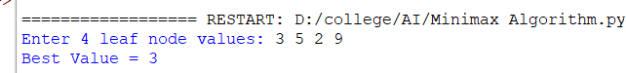

Result:
Thus, the Minimax algorithm was implemented successfully using Python. The algorithm evaluated all possible game states recursively and displayed the optimal decision value for the given game tree.

